
Company
Logotype

Cone Beam Computed Tomography- Report



Porur Dental X-rays & CBCT

Patient Name : Mrs. Sangeetha | Date of Report : 08.03.2024
Age/ Gender : 27 years/ Female | Region of Interest : CBCT Mandible
Referring doctor: Dr. H. S. Ramlal Joshi | Indication : Impacted tooth
Clinical Notes: Nil
PATIENT INFORMATION

CBCT- Mandible provided
CBCT – IMAGE DETAILS

RADIOGRAPHIC INTERPRETATION

- The long axis of 38 appears to be horizontal to the long axis of the adjacent 37 tooth.
- The crown of 38 is present partially within the alveolar bone of mandible.
- Distance between the crown of 38 and the Inferior Alveolar Nerve canal: 3.09 mm
- Distance between the radicular portion of 38 and the Inferior Alveolar Nerve canal: in contact.

RADIOGRAPHIC IMPRESSION

- Horizontally impacted tooth: 38

Kindly correlate with clinical findings


IMAGES FOR REFERENCE

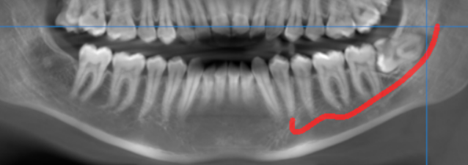

3-DIMENSIONAL VIEW

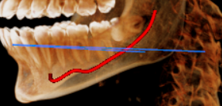

CROSS SECTIONAL VIEW

38 region- root in contact with the inferior alveolar nerve canal | 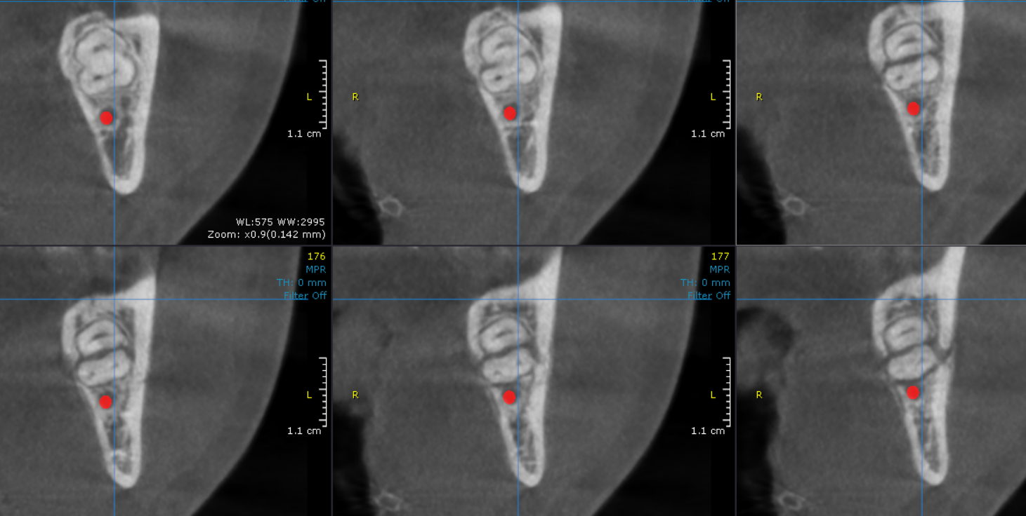

**** End of report ****

